Road Safety and Simulation 2026 – RSS2026
Multi-LLM framework for Automated Extraction and Analysis of Road Accident Narratives from Unstructured Text
Abhijnan Majiª, Sachin Prasanth^{b}, Omprakash Rout^{b}, Indrajit Ghoshª
ªDepartment of Civil Engineering, Indian Institute of Technology (IIT) Roorkee, Roorkee 247667, India
^{b}Department of Computer Science & Engineering, SRM Institute of Science and Technology, Chennai 603203, India
Abstract
Road traffic crash analysis forms the basis of transportation safety planning and policy development; however, its effectiveness is constrained by the lack of quality data. In many low- and middle-income countries, official crash databases remain incomplete and limited in contextual detail. The lack of granular information such as precise location, pavement conditions, vehicles involved, crash causation factors, and time of occurrence prevents engineers from identifying high-risk black spots and implementing effective safety interventions. At the same time, regional newspapers document road accidents with rich text-based descriptions of circumstances, location, timing, and outcomes. Despite their informational value, these narratives remain largely unutilized due to their unstructured and heterogeneous nature. Recent advances in natural language processing provide an opportunity to bridge this gap by enabling automated interpretation of free-text data at scale. Leveraging large language models (LLMs), this study develops an integrated approach for identifying accident-related reports/articles and extracting structured, transportation-relevant crash attributes. An automatically generated crash dataset was constructed from unstructured news narratives and validated using multiple large language models to ensure robustness and consistency. Analysis of the dataset indicates higher crash occurrence at intersections at 63% and a predominance of rear-end collisions at 65%, with peaks during weekday evenings and weekend mid-days and a 31% increase during monsoon months. Injury severity distributions of 1.2% fatal, 18.7% serious injury, and 80.1% minor injury align with national crash statistics, highlighting the utility of automated text-derived crash data for transportation safety analysis.
© 2026 The Authors. Published by ELSEVIER B.V.
This is an open access article under the CC BY-NC-ND license (https://creativecommons.org/licenses/by-nc-nd/4.0)
Peer-review under responsibility of the scientific committee of the Road Safety and Simulation 2026 – RSS2026
Keywords: Roundabout Safety, Heterogeneous Traffic; Surrogate Safety Measures (SSM); Geometric and Traffic Parameter Optimization; Unmanned Aerial Vehicle (UAV); Trajectory Data;
Introduction
Road traffic crashes represent a major global challenge, with low- and middle-income countries (LMICs) accounting for a disproportionate share of fatalities and injuries worldwide. Effective transportation safety planning and policy development depend on the availability of accurate and context-rich crash data (Li et al., 2024). However, in many LMICs, including India, official police-based crash databases suffer from unavailability of data, persistent under-reporting, and lack of location information (Maji & Ghosh, 2025b). One of the prior studies have reported that approximately 60–70% of crash records in such databases are incomplete, resulting in the loss of critical contextual information required for analysis and policy assessment (Lopez et al., 2022). The absence of granular details such as precise crash location, pavement conditions, mechanical failure specifics, crash causation, and time of occurrence significantly limits the ability of transportation engineers to identify high-risk locations, evaluate contributing factors, and implement effective safety interventions (Maji & Ghosh, 2025a, 2025c). In the absence of such high-resolution data, resource allocation for road safety becomes reactive rather than proactive, often failing to reach the most vulnerable road users.
Conventional crash datasets therefore provide limited support (due to unavailability and unreliability) for detailed spatiotemporal analysis, black spot identification, and evidence-based decision-making. These limitations are particularly restrictive in LMICs like India, where heterogeneous traffic conditions, and infrastructure constraints exacerbate crash risk (Maji et al., 2024). At the same time, regional newspapers and digital media routinely document road traffic crashes with rich narrative descriptions of circumstances, location, timing, vehicle interactions, and injury outcomes. Such reports often contain situational and contextual details absent from official records, offering a potentially valuable supplementary data source for transportation safety analysis (Chowdhury et al., 2024). Despite their informational richness, these narratives remain largely underutilized due to their unstructured, heterogeneous, and dispersed nature, making large-scale aggregation and systematic analysis infeasible through manual or traditional data processing approaches (Labib et al., 2019; Paul et al., 2020).
Early attempts to leverage textual crash narratives relied on manual curation or simple automated techniques focused on keyword matching and predefined categories (Hosseini et al., 2023). While these approaches enabled limited extraction of specific attributes, they were difficult to scale and highly sensitive to linguistic variability across reporting styles and regions (Mumtarin et al., 2023). As the volume and diversity of digital news content increased, such methods proved insufficient for capturing the semantic complexity required for comprehensive transportation safety analysis. Consequently, narrative crash data remained largely isolated from mainstream safety analytics, despite its recognized potential value (Mumtarin et al., 2023).
Recent advances in natural language processing, particularly the emergence of large language models (LLMs), have altered the feasibility of extracting structured information from free-text data at scale (Gojare et al., 2015; Khavas & Nosrati, 2025; Mumtarin et al., 2023; Reddy et al., 2024). Unlike earlier rule-based or feature-engineered methods, LLMs can capture contextual relationships and implicit information across heterogeneous narratives, enabling more robust interpretation of unstructured text (Roumeliotis et al., 2024). Crash narratives often involve ambiguous phrasing, long contextual dependencies, and implicit references to causation and injury outcomes, which are difficult to resolve using shallow text-processing approaches (Zhen et al., 2022). Although emerging research has demonstrated the potential of NLP-based approaches for extracting transportation-related information, their application to large-scale crash data generation remains limited (Khavas & Nosrati, 2025).
In this context, the present study explores the use of LLMs to help address limitations associated with unstructured accident narratives by enabling automated extraction of road traffic crash information. By converting free-text news reports into structured variables suitable for engineering analysis, the study examines whether such text-derived data can support meaningful insights, including collision-type and injury-severity analyses, in data-constrained environments. Rather than replacing official crash databases, this work considers narrative-derived crash data as a complementary source that may help fill existing information gaps and support transportation safety analysis and planning where conventional data are unavailable, unreliable, and limited.
Accordingly, the objectives of this study are threefold:
• To examine the feasibility of generating structured crash data from unstructured news narratives.
• To analyses the safety patterns that emerge from the resulting dataset.
• To assess the potential of text-derived crash information as a supplementary resource for transportation safety analysis in data-limited contexts.
Methodology
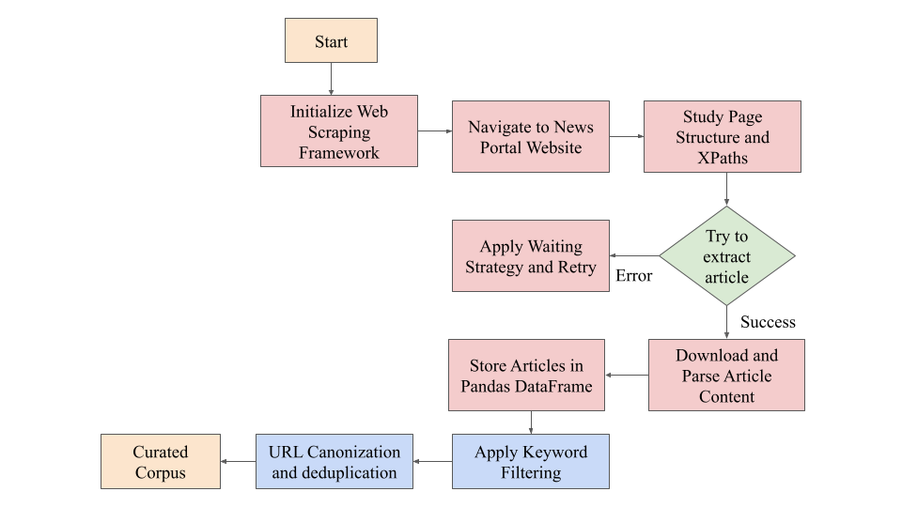
The overall framework comprises a multi-stage processing pipeline for transforming unstructured news narratives into structured, transportation-relevant crash data. As illustrated in Fig. 1 and Fig. 2, the framework integrates automated web scraping with large language model (LLM) - based classification and structured information extraction. The pipeline combines automated web-based data collection with large language model-driven classification and structured information extraction, followed by normalisation and validation steps. The overall framework comprises four sequential stages: data collection and preprocessing, accident classification, structured information extraction, and dataset generation.
Fig. 1. Web-scraping pipeline for crash news collection. The flowchart illustrates the automated pipeline for collecting accident-related news articles, starting with initialization of the web-scraping framework and navigation to target news portals. Page structures and XPaths are analysed to enable robust article extraction, with retry and waiting strategies handling dynamic loading and extraction failures. Successfully retrieved articles are downloaded, parsed, and stored in a structured dataframe, followed by keyword-based filtering and URL canonicalization with deduplication to produce a curated corpus of unique, relevant crash narratives suitable for downstream analysis.
Data Collection and Web Scraping
Accident-related news articles were gathered from major Indian online news platforms, namely Times of India, NDTV, and Hindustan Times, which regularly publish detailed coverage of road traffic incidents and were selected due to their nationwide coverage, regular reporting of traffic incidents, and availability of structured online archives. These outlets were selected to ensure wide geographic representation, temporal continuity, and diversity in reporting styles across regions. A custom web-scraping framework was developed to collect content from both static webpages and dynamically rendered articles. For each news report, essential metadata, including a unique article identifier, title, publication source, URL, and full textual content, was extracted and stored. To enhance data quality and relevance, an initial keyword-based filtering step was applied to retain only articles likely to describe road traffic accidents.
As the same incident is often reported by multiple outlets or redistributed through syndicated content, duplicate and near-duplicate articles were identified using a two-stage deduplication procedure. First, URL canonicalization was applied to remove exact duplicates arising from syndicated or redirected links. Second, semantic similarity between article texts was used to identify reports describing the same crash event across multiple news outlets. Articles with highly similar narrative descriptions were grouped and treated as reports of the same underlying crash incident, with a single representative article retained for downstream analysis. Fig. 1 outlines the web-scraping and preprocessing pipeline used to collect, filter, and deduplicate accident-related news articles

Algorithm 1. Pseudocode for crash news data collection and preprocessing

1 Initialize the web scraping framework
2 Define the list of news portals

3 For each news portal do
4 Access the webpage and identify the required XPaths

5 For each article do
6 Attempt to extract content
7 If extraction fails, apply a waiting strategy and retry
8 Download and parse the article
9 Store article details (title, URL, text, metadata)
10 End
11 End

12 Apply keyword-based filtering to retain relevant articles
13 Perform URL canonicalization
14 Remove duplicate and near-duplicate articles

15 Return the curated dataset

Following this process, the data collection effort produced a corpus of 2,330 unique accident-related news narratives representing distinct crash reports, after keyword filtering and semantic deduplication from an initial pool of 2,500 scraped articles. The dataset spans from April 4, 2018 to July 14, 2025, with the final dataset snapshot frozen on July 14, 2025. The final dataset comprises 25 Indian cities. This broader temporal coverage enables the analysis of both recent trends and longer-term patterns in road accidents, helping to reduce short-term reporting bias and supporting more reliable spatio-temporal safety analysis.
Accident Classification Using Large Language Models and Selection
The collected articles were subsequently subjected to a multi-class classification stage to distinguish road traffic crash reports from unrelated content. Each article was assigned to one of three predefined categories:
• Class 1: Road Accident – Articles explicitly describing traffic crashes occurring on roads or highways involving vehicles.
• Class 2: General Accident – Non-road accidents such as railway incidents, industrial mishaps, or falls.
• Class 3: Other / Non-Accident – Articles unrelated to accidental events, including opinion pieces, crime reports, or general news.
After the classification stage, 2,245 articles were identified as specific road accident reports, 71 as general accident news, and 14 as non-accident articles. To improve robustness and reduce model-specific bias, multiple Large Language Models were employed independently for the classification task. Fig. 2 presents the LLM-driven workflow for article classification, information extraction, and dataset generation. Models evaluated in zero-shot mode included ‘openai/gpt-oss-20b’, ‘qwen/qwen3-32b’, ‘llama-3.3-70b-versatile’, and ‘llama-4-scout-17b-16e-instruct’. A unified prompt template was used across all models to enforce consistent output formats and label definitions. Classification outputs were stored in structured tabular form and evaluated against a manually annotated ground-truth dataset using standard evaluation metrics, including accuracy, precision, recall, and F1-score. Only articles classified as Class 1 (Road Accident) were retained for subsequent information extraction. This filtering step ensured that extraction models operated exclusively on relevant road traffic crash narratives, thereby reducing noise and limiting error propagation to downstream stages. All retained articles preserved their original metadata to maintain traceability between classification and extraction outputs. The present study focuses on evaluating the capability of multiple large language models for crash narrative classification and structured extraction. Consequently, the comparison is conducted across different LLM architectures rather than against traditional rule-based or classical NLP baselines.
Structured Information Extraction
Structured accident attributes were extracted from the filtered road accident articles using a prompt-driven, schema-constrained extraction approach. Carefully designed LLM-based prompts guided the models to map free-text narratives into a predefined JSON schema capturing transportation-relevant crash information, including:
• Accident location and state
• Date and time of occurrence
• Intersection type
• Collision type
• Vehicles involved
• Accident severity
• Number of fatalities and injuries
• Pedestrian involvement
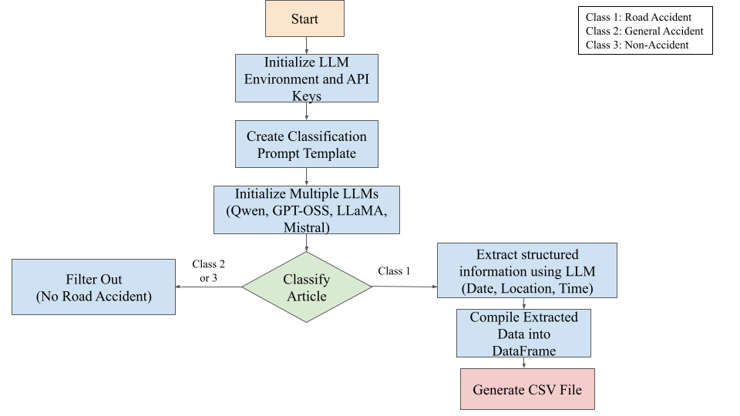
The extraction prompts explicitly enforced field-level constraints, controlled vocabularies for categorical variables, and standardised handling of missing or ambiguous information using predefined labels. Each article was processed independently to ensure consistency at the record level across heterogeneous reporting styles. The raw model outputs were subsequently validated and normalised to ensure consistency across records. Rule-based post-processing was applied to standardise categorical variables and resolve partially specified or ambiguous fields using predefined mappings. Location attributes were extracted directly from the news narratives using the LLM-based structured extraction prompts. The model identified city and state names as well from the article text and mapped them to predefined geographic categories. Model inference was performed using deterministic decoding settings with temperature set to 0.0 and a maximum token limit of 1000. All models were evaluated using zero-shot prompting. Rule-based post-processing further normalised model outputs into controlled vocabularies for structured attributes. For example, phrases such as “traffic light” were mapped to “Signalised,” “rear-ended” to “Rear End,” and “skidded” to “Single Vehicle Collision.” If one or more fatalities were mentioned in the narrative, the severity label was assigned as “Fatal,” while missing or unspecified attributes were assigned a standard “NA” label. In cases where narratives contained conflicting information such as different casualty counts within the same article, the extraction process retained the most severe outcome mentioned in the report, ensuring consistent representation of crash severity in the structured dataset.
Figure 2: Multi-LLM–based classification and information extraction pipeline: The flowchart presents the end-to-end LLM-driven processing of news articles, beginning with initialization of the LLM environment and unified prompt templates. Multiple large language models are used in parallel to classify articles into road accident, general accident, and non-accident categories, with non-relevant articles filtered out. Articles identified as road accidents undergo structured information extraction to identify key crash attributes such as date, time, and location, which are then compiled into a standardized tabular dataset for subsequent analysis.
Dataset Generation and Validation
The final output of the pipeline is a standardized crash dataset generated from unstructured news narratives. Extraction and classification performance were evaluated using manually annotated ground-truth subsets. A total of 700 articles were manually annotated for classification validation, while 300 articles were used for structured information extraction evaluation. Manual annotation was conducted by a primary annotator with domain familiarity in transportation safety and natural language processing. All annotations were independently reviewed by a second researcher, and disagreements were resolved through consensus-based adjudication where necessary. As the annotation process involved primary labeling followed by verification rather than independent blind annotation, formal inter-annotator agreement statistics such as Cohen’s kappa were not computed. Standard evaluation metrics including accuracy, precision, recall, and F1-score were computed for model comparison across models. For structured information extraction, per-field macro-averaged precision, recall, and F1-scores were computed for attributes including severity, collision type, vehicle types, killed, injured, pedestrian involvement, location, state, date, and time.
Results and Discussion
Model Performance and Classification Reliability
The comparative evaluation of large language models indicates substantial variation in classification performance. Qwen achieved the highest accuracy at 94%, with an F1 score of 0.93, precision of 0.945, and recall of 0.94. GPT-OSS followed with 92%t accuracy and an F1 score of 0.90. In contrast, LLaMA4 and LLaMA3.3 achieved accuracies of 72% and 74%, respectively, with comparatively lower F1 scores. The results demonstrate that recent large language models can reliably distinguish road accident narratives from unrelated content, thereby significantly reducing noise in downstream processing. The superior performance of Qwen and GPT-OSS highlights the importance of contextual reasoning capacity in interpreting heterogeneous news text. Given its balanced precision and recall, Qwen was adopted as the primary model for structured data extraction to minimize error propagation within the pipeline. Confusion matrices were generated for severity and collision type to further analyze model misclassification patterns across the evaluated models.
Table 1. Comparative classification performance of large language models for road accident identification.
Model | Accuracy | Precision | Recall | F1 Score
GPT | 0.91 | 0.89 | 0.90 | 0.89
Qwen3 | 0.94 | 0.94 | 0.93 | 0.93
LLaMA 4 | 0.70 | 0.67 | 0.68 | 0.67
LLaMA 3.3 | 0.73 | 0.69 | 0.70 | 0.69
Structured Extraction and Crash Pattern Analysis
The schema-constrained extraction framework successfully transformed unstructured news narratives into structured crash attributes. A majority of crashes were reported at intersections, accounting for 63% of cases. Rear-end collisions represented 65% of all crashes, indicating less headway keeping dynamics and erratic speeding-related interactions as dominant contributing factors. These findings are consistent with known roadway conflict patterns in dense urban traffic environments. Temporal distribution analysis revealed peak crash occurrence during weekday evenings and weekend mid-days. A 31% increase in reported crashes was observed during monsoon months (June–September), suggesting sensitivity to adverse weather conditions and reduced pavement friction. The temporal trends align with established associations between traffic exposure, environmental factors, and crash risk. The reported increase was calculated by comparing the average number of crash reports during monsoon months with the average monthly crash frequency during the remaining months of the year. The extracted crash reports span multiple regions across India through coverage of 25 cities.
Severity Distribution and Implications for Road Safety Analysis
The extracted injury severity distribution comprised 1.2% fatal, 18.7% serious, and 80.1% minor injuries, indicating that minor injury cases constitute the majority of reported outcomes in the dataset. The consistency between extracted trends and established transportation safety patterns supports the analytical validity of the proposed framework. While media-based datasets may inherently contain exact location reporting bias, the results demonstrate that structured information derived from unstructured text can provide meaningful insights for hotspot identification, temporal risk assessment, and safety planning. The temporal attributes used for this analysis were derived from the LLM-based structured extraction outputs, where date and time information mentioned in the article narratives were automatically identified and assigned as structured fields. The observed seasonal patterns therefore represent descriptive trends in the extracted dataset.
Overall, the findings confirm that a multi-LLM pipeline can generate reliable, structured crash datasets from heterogeneous news narratives. The framework offers a scalable and technically robust approach for supplementing conventional crash databases, particularly in data-constrained contexts. The structured dataset generated through the proposed framework provides a foundation for simulation-based safety modeling, enabling road infrastructure risk simulation, temporal exposure modeling, and scenario-based crash prediction in environments where official datasets lack granularity and reliability. This enhances the feasibility of proactive infrastructure planning in data-constrained regions.
Conclusions
This study presents a multi-LLM–based framework for automated extraction and structuring of road accident data from unstructured news narratives. The results demonstrate that large language models can reliably classify accident-related reports with high accuracy, with Qwen achieving 94% accuracy and strong precision–recall balance. The structured extraction pipeline successfully generated transportation-relevant crash attributes suitable for quantitative safety analysis. The derived dataset revealed analytically consistent patterns, including a predominance of intersection-related crashes, a high share of rear-end collisions, identifiable temporal peaks, and a seasonal increase during monsoon months. The extracted injury severity distribution aligned with national trends, supporting the validity of narrative-derived crash data for transportation safety research. The dataset incorporates reports from major national outlets covering multiple regions of India, thereby ensuring broad geographic representation.
A limitation of the present framework is that it processes only English-language reports, although these sources cover regional events across the country. Future work will extend the system to multilingual regional-language news to further enhance representativeness, reduce potential linguistic bias, and strengthen inclusivity in crash data generation. From a computational perspective, the framework relies on LLM inference in zero-shot mode without fine-tuning, reducing overall computational requirements. The modular pipeline allows articles to be processed sequentially and can be integrated with either open-source or hosted LLM services, enabling scalable deployment for large-scale crash data extraction.
Overall, the proposed framework provides a scalable and technically robust approach for supplementing conventional crash databases in data-constrained environments. By converting heterogeneous textual reports into structured datasets, the system enables proactive safety assessment and supports data-driven road safety assessment and planning.
References
Chowdhury, T. B. Z., Islam, R., & Hossain, M. (2024). Durghotona GPT : A Web Scraping and Large Language Model Based Framework to Generate Road Accident Dataset Automatically in Bangladesh. 2024 27th International Conference on Computer and Information Technology (ICCIT), December, 50–55. https://doi.org/10.1109/ICCIT64611.2024.11021969
Gojare, S., Joshi, R., & Gaigaware, D. (2015). Analysis and Design of Selenium WebDriver Automation Testing Framework. Procedia - Procedia Computer Science, 50, 341–346. https://doi.org/10.1016/j.procs.2015.04.038
Hosseini, P., Khoshsirat, S., Jalayer, M., & Das, S. (2023). International Journal of Transportation Application of text mining techniques to identify actual wrong-way driving ( WWD ) crashes in police reports. International Journal of Transportation Science and Technology, 12(4), 1038–1051. https://doi.org/10.1016/j.ijtst.2022.12.002
Khavas, R. G., & Nosrati, M. (2025). Extracting Traffic Crash Information from Social Media: An LLM-based Approach. https://ssrn.com/abstract=5379743
Labib, F., Rifat, A. S., Hossain, M., Das, A. K., & Nawrine, F. (2019). Road Accident Analysis and Prediction of Accident Severity by Using Machine Learning in Bangladesh. 2019 7th International Conference on Smart Computing & Communications (ICSCC), 1–5.
Li, L., Zhang, Z., Xu, Z. G., Yang, W. C., & Lu, Q. C. (2024). The role of traffic conflicts in roundabout safety evaluation: A review. Accident Analysis and Prevention, 196(April 2023). https://doi.org/10.1016/j.aap.2023.107430
Lopez, D., Malloy, L. C., & Arcoleo, K. (2022). Police narrative reports : Do they provide end-users with the data they need to help prevent bicycle crashes ? Accident Analysis and Prevention, 164(November 2021), 106475. https://doi.org/10.1016/j.aap.2021.106475
Maji, A., & Ghosh, I. (2025a). A copula-based multivariate extreme value framework for roundabout safety evaluation under mixed traffic. Accident Analysis and Prevention, 221(June), 108219. https://doi.org/10.1016/j.aap.2025.108219
Maji, A., & Ghosh, I. (2025b). A systematic review on roundabout safety incorporating the safety assessment methodologies, data collection techniques, and driver behavior. Safety Science, 181(September 2024), 106661. https://doi.org/10.1016/j.ssci.2024.106661
Maji, A., & Ghosh, I. (2025c). Advanced traffic conflict analysis for safety evaluation at roundabouts under mixed traffic using extreme value theory. Accident Analysis and Prevention, 219(November 2024), 108108. https://doi.org/10.1016/j.aap.2025.108108
Maji, A., Ghosh, I., & Chandra, S. (2024). Development of conflict-based safety performance function for safety evaluation of urban roundabouts in India. Canadian Journal of Civil Engineering, 52(4), 498–515. https://doi.org/10.1139/cjce-2024-0314
Mumtarin, M., Chowdhury, M. S., & Wood, J. (2023). Large Language Models in Analyzing Crash Narratives - A Comparative Study of Chatgpt, Bard And Gpt-4.
Paul, J., Jahan, Z., Lateef, K. F., Islam, M. R., & Bakchy, S. C. (2020). Prediction of Road Accident and Severity of Bangladesh Applying Machine Learning Techniques. 2020 IEEE 8th R10 Humanitarian Technology Conference (R10-HTC). https://doi.org/10.1109/R10-HTC49770.2020.9356987
Reddy, N. S., Ruthvik, B., Maheshwari, M., Shabu, J. L. J., & Refonaa, J. (2024). Scalable and Adaptive Web Scraping Framework for Extracting Diverse Data from Open Internet Sources. 2024 4th International Conference on Pervasive Computing and Social Networking (ICPCSN), 872–877. https://doi.org/10.1109/ICPCSN62568.2024.00147
Roumeliotis, K. I., Tselikas, N. D., & Nasiopoulos, D. K. (2024). LLMs in e-commerce : A comparative analysis of GPT and LLaMA models in product review evaluation. Natural Language Processing Journal, 6(November 2023), 100056. https://doi.org/10.1016/j.nlp.2024.100056
Zhen, H., Shi, Y., Huang, Y., Yang, J. J., & Liu, N. (2022). Leveraging Large Language Models with Chain-of-Thought and Prompt Engineering for Traffic Crash Severity Analysis and Inference.

* Corresponding author. Tel.: +91-1332-285533; fax: +91-1332-275568. E-mail address: indrafce@iitr.ac.in

